29-1 NAT Configuration – Lab Exercise

In this lab you will configure static and dynamic Network Address Translation, and Port Address Translation.

The routers, servers and PCs have been configured with their network addressing settings.

R1 is the WAN edge router at your company, it has a default route pointing to the Service Provider router SP1.

You have bought the range of public IP addresses 203.0.113.0/28. 203.0.113.1 is assigned to the Service Provider default gateway SP1, 203.0.113.2 is assigned to the Internet facing F0/0 interface on your router R1. 203.0.113.3 – 203.0.113.14 are your remaining available public IP addresses.

Note that entries in the NAT translation table age out quickly. Send the traffic again if you do not see the expected results in the table.

Lab Topology

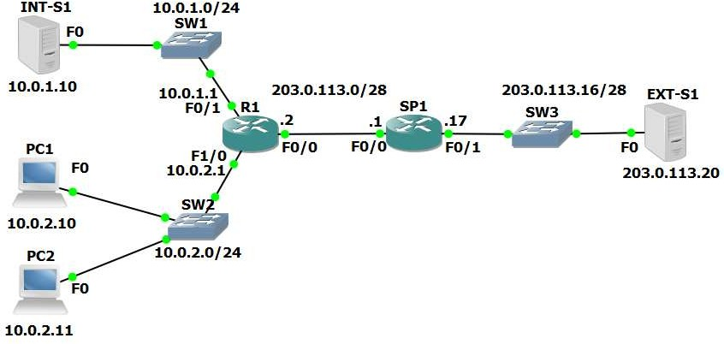

Load the Startup Configurations

Open the ’29-1 NAT Configuration.pkt’ file in Packet Tracer to load the lab.

Static NAT

- Int-S1 is your company’s web server. It must be reachable from external customers browsing the Internet. Configure NAT on R1 so that external customers can reach the server using the public IP address 203.0.113.3. Do not change any IP addressing or routing information.

- Ping Ext-S1 from Int-S1 to check the NAT rule is working and you have connectivity.

- On Ext-S1, click on ‘Desktop’ then open ‘Web Browser’. Open the NAT’d public IP address of Int-S1 at https://203.0.113.3 in the browser to verify that external customers on the Internet can reach your web server.
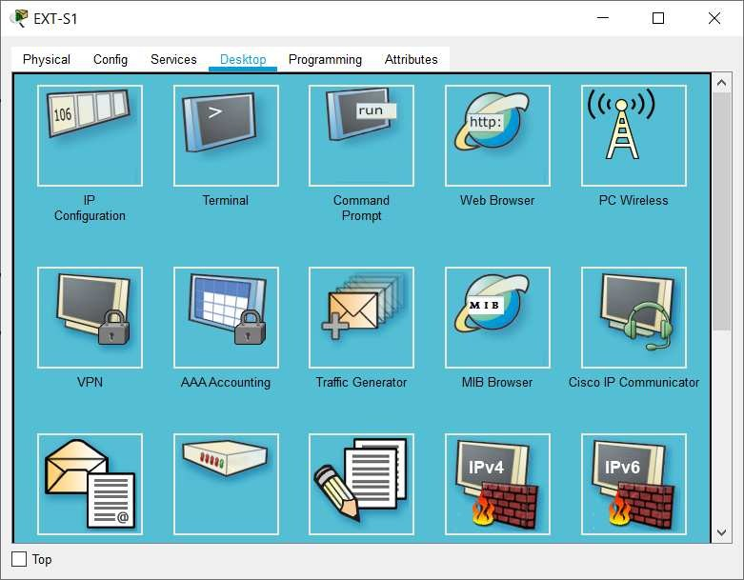

You will see the output shown below if your configuration is working:
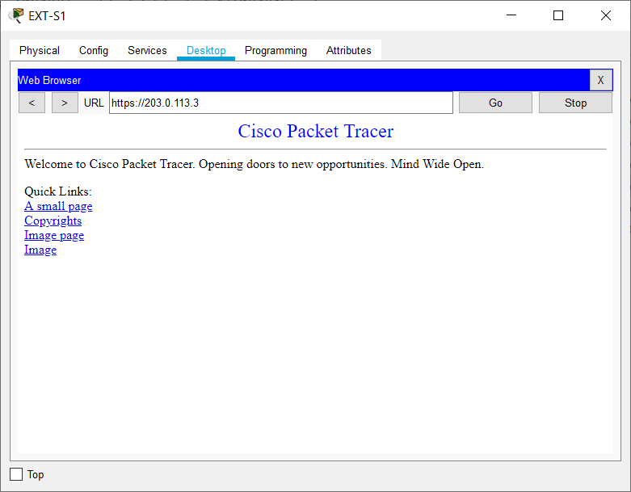

You will see a ‘Request Timeout’ error message if your configuration is
not working (you need to fix it):
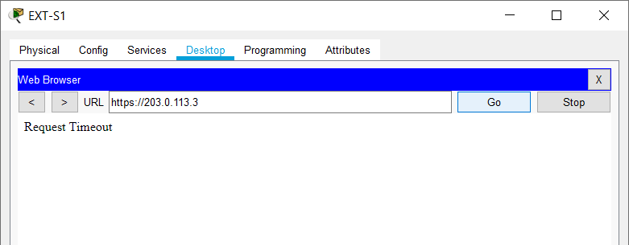

- Verify the connection appears in the NAT translation table. Note that entries age out quickly so generate the traffic again if you did not check the table quickly enough.

Dynamic NAT

- Configure NAT on R1 so that PCs in the 10.0.2.0/24 subnet have connectivity to external networks on a first come first served basis. Assign global addresses from the range 203.0.113.4 to 203.0.113.12. Do not enable Port Address Translation.

- Turn on NAT debugging on R1. Ping Ext-S1 from PC1. View the debug output on R1. You should see NAT entries for the 5 pings. Which global address was PC1 translated to?

- Verify the ping connection appears in the NAT translation table.

- When all the addresses in the pool 203.0.113.4 to 203.0.113.12 have been allocated, what will happen when the next PC tries to send traffic to an external host?

- Enable Port Address Translation so that the last IP address in the range can be reused when all IP addresses have been allocated to clients.

- Cleanup: Completely remove the access list and all NAT configuration from R1. Use the commands ‘show run | section nat’ and ‘show access- list’ to verify all configuration is removed.

Port Address Translation PAT

- Your company no longer has a range of public IP addresses. Instead you will receive a single public IP address via DHCP from your service provider.

Shutdown interface F0/0 on R1 and remove its IP address. Reconfigure it to receive its IP address via DHCP from the service provider router SP1.

- Bring the interface back up and wait for DHCP. What IP address is it assigned?

- Configure NAT on R1 so that PCs in the 10.0.2.0/24 subnet have connectivity to external networks on a first come first served basis. Allow multiple PCs to reuse the IP address on interface F0/0 on R1. Ensure that NAT continues to work if the DHCP address assigned by the provider changes.

- Ensure NAT debugging on R1 is still enabled. On PC1, click on ‘Desktop’ then open ‘Web Browser’. Open the public IP address of Ext-S1 at https://203.0.113.20 in the browser to verify that PAT is working and you can reach external servers.
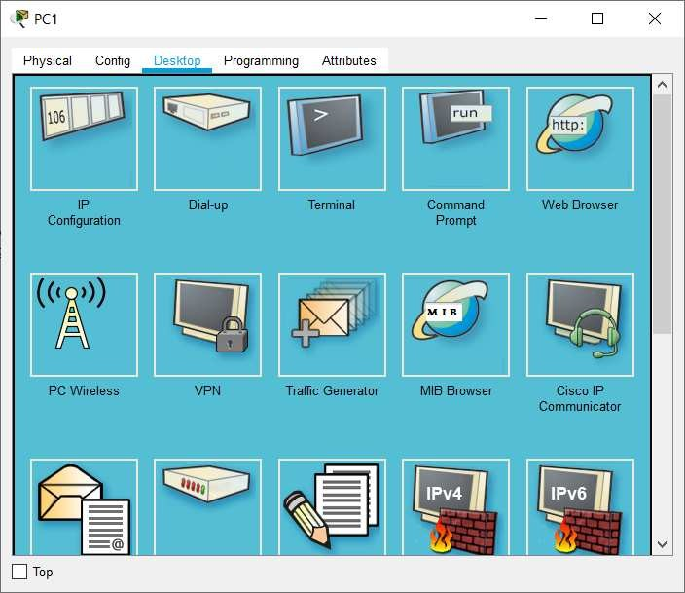

You will see the output shown below if your configuration is working:
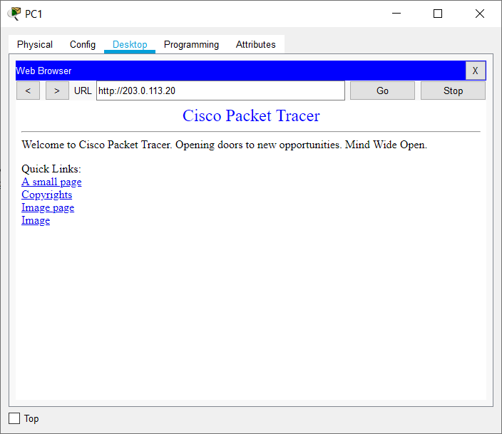

You will see a ‘Request Timeout’ error message if your configuration is
not working (you need to fix it).

- View the debug output on R1. Which global IP address was PC1 translated to?

- On PC2, click on ‘Desktop’ then open ‘Web Browser’. Open the public IP address of Ext-S1 at http://203.0.113.20 in the browser. Which global IP address is PC2 translated to?

- Verify the connections in the NAT translation table.

- Show the NAT statistics on R1.

